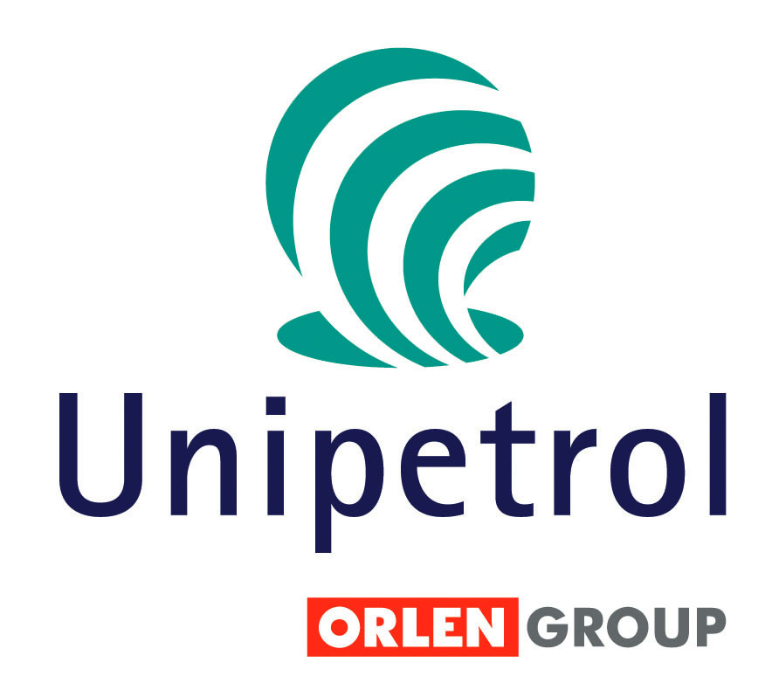
Radek Nemecek
Investor Relations
UNIPETROL, a.s.
Klimentska 10 Prague 110 05
Tel: +420 225 001 417
GSM: +420 736 502 562
Email: radek.nemecek@unipetrol.cz
www.unipetrol.cz

Inside Information Dec 14, 2006

Conclusions from Today’s General Meeting of Ceska Rafinerska, a.s.

The General Meeting of Ceska Rafinerska, a.s. decided that 2005 profit of CZK 256 997 907.15 will be distributed as follows:

a) allotment to the statutory reserve fund of CZK 12 849 923.07;
b) the remaining part of profit of CZK 244 147 984.08 be paid to shareholders as dividends, each share with the nominal value CZK 10 000 would be entitled to a dividend equal to CZK 261.17, before tax.

The Company shall pay out dividends to Shareholders by no later than 22 December 2006. UNIPETROL, a.s. will receive a dividend in the amount of 124 505 224 Kč before tax.

The shareholders of Ceska Rafinerska, a.s. agreed that the total CAPEX in 2007 will not exceed CZK 1,973 bn. Ceska Rafinerska plans to process approx. the same amount of crude oil in the year 2007 as in the year 2006.

Česká Rafinerska is the largest crude oil processing company in the Czech Republic. It operates refineries in Litvinov and Kralupy nad Vltavou. Ceská Rafinérska is a joint venture of 4 shareholders: Unipetrol (51%), ENI (16,3%), Shell (16,3%) and ConocoPhillips (16,3%.

- - END OF ANNOUNCEMENT - - -

