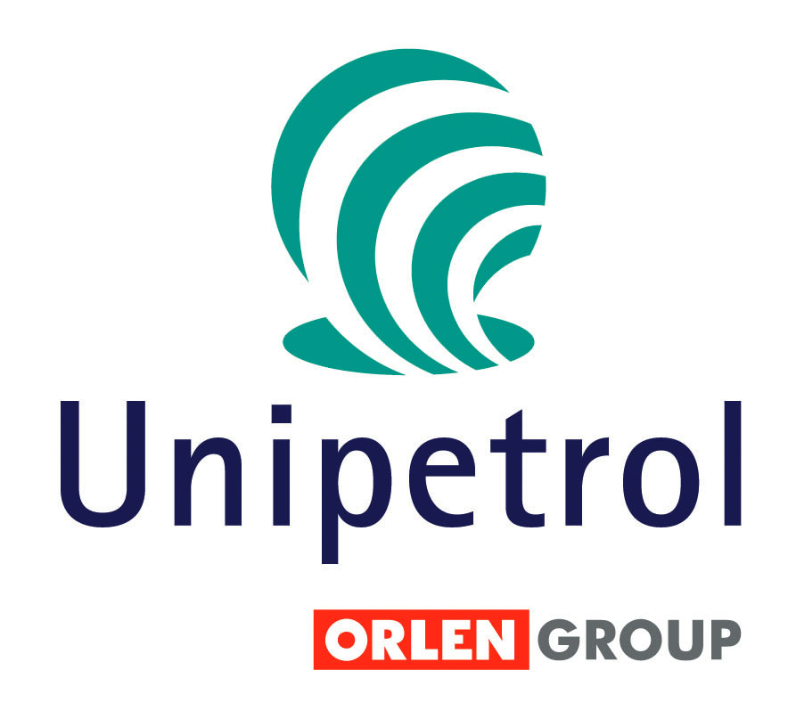
Radek Nemecek
Investor Relations
UNIPETROL, a.s.
Klimentska 10 Prague 110 05
Tel: +420 225 001 417
GSM: +420 736 502 562
Email: radek.nemecek@unipetrol.cz
www.unipetrol.cz

Internal information Dec 20, 2006

Shutdown of the FCC facility in Kralupy

On 15.12.2006 an inspection was conducted of the fluid catalytic cracking facility at the Kralupy site of Česká rafinérská, a.s. and as a result it was decided that on 19.12.2006 the facility will be shut down due to turbine repair. The estimated length of the shutdown is 2-3 weeks. For UNIPETROL RAFINÉRIE, a.s., a 100% subsidiary of UNIPETROL, a.s. and a processor in Česká rafinérská, a.s. this shutdown will mean a cut-off of fuels deliveries which will have to be covered from other sources and by purchases. Financial result of this unplanned shutdown UNIPETROL RAFINÉRIE, a.s. will be able to calculate only after it is over and the status before the shutdown is restored.

- - END OF ANNOUNCEMENT - - -

