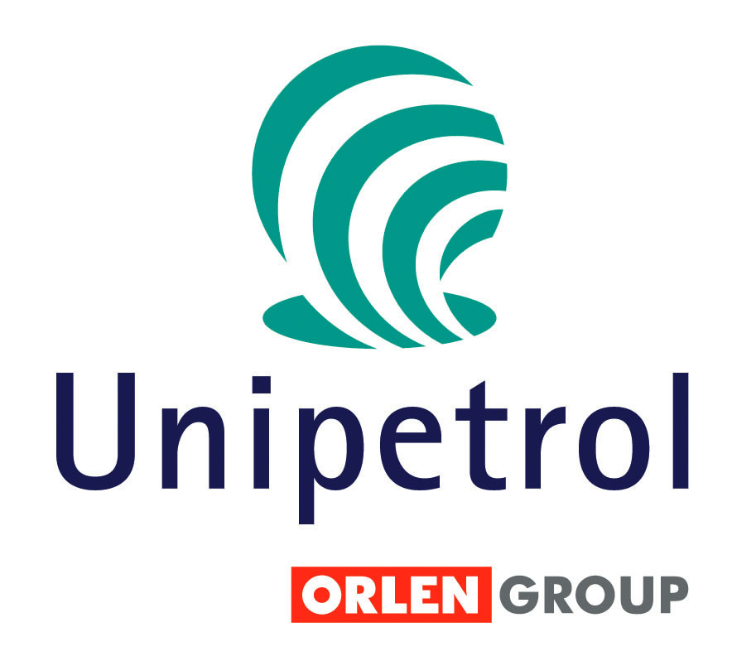
Radek Nemecek
Investor Relations
UNIPETROL, a.s.
Klimentska 10 Prague 110 05
Tel: +420 225 001 417
GSM: +420 736 502 562
Email: radek.nemecek@unipetrol.cz
www.unipetrol.cz

Inside information Apr 22, 2007

Transformation of UNIPETROL TRADE, a.s

The project of New Corporate Governance in UNIPETROL Group was launched in the 2nd half of 2006 with the strategic objective of increasing the competitiveness of the Group through simplification and standardisation of organisation’s structure, implementation of new business models and focus on key business areas.

Transformation of UNIPETROL TRADE, a.s. (a 100% subsidiary of UNIPETROL, a.s.) is the integral part of this plan.

In accordance with the decision to change the commercial strategy, a restructuring plan was prepared for UNIPETROL TRADE a.s. and its foreign affiliates. The basic principle of the transformation of UNIPETROL TRADE, a.s. is the change in commercial activities on foreign markets and adjustment of the business infrastructure to the requirements of the newly created Business Units of UNIPETROL Group. During 2007 the commercial activities will be centralised in the Business Units of UNIPETROL Group and the business administration will be transferred to UNIPETROL Services, s.r.o.

After transferring the commercial activities of UNIPETROL TRADE, a.s. to the Business Units in the 2nd half of 2007, decisions will be made concerning liquidation or disposal of foreign affiliates of UNIPETROL TRADE a.s. The capital market will be informed about this decision in due time.

- - END OF ANNOUNCEMENT - -

